**QUALITY ASSURANCE TRAINING**

**Introduction to QA**

| **Submitted By:** | **Submitted To:** |
| --- | --- |
| **Nischal Shrestha** | **Prajesh Shakya** |

**Date:7th March, 2025**

# ABSTRACT

This report introduces the essential concepts of Quality Assurance within the context of software development. It examines the distinction between QA and Quality Control (QC), and details the various stages of QA implementation within the Software Development Life Cycle (SDLC). The report discusses key testing methodologies, including black-box and white-box testing, and highlights the importance of proactive defect prevention.

# TABLE OF CONTENTS

**ABSTRACT 2**

**TABLE OF CONTENTS 3**

**LIST OF ABBREVIATIONS 7**

**QUALITY ASSURANCE 8**

Introduction 8

Plan 9

Do 9

Check 9

Act 9

Definition of Quality 9

Quality Control 9

Software Quality Assurance (SQA) 11

Elements of SQA 12

Software Development Life Cycle (SDLC) 13

Importance of SDLC 13

Stages of SDLC 14

Stage-1: Planning and Requirement Analysis 14

In-Depth Activities 15

Deliverables 15

Stage-2: Defining Requirements 15

In-Depth Activities 15

Deliverables 15

Stage-3: Designing Architecture 15

In-Depth Activities 16

Deliverables 16

Stage-4: Developing Product 16

In-Depth Activities 17

Deliverables 17

Stage-5: Product Testing and Integration 17

In-Depth Activities 18

Deliverables 18

Stage-6: Deployment and Maintenance of Products 18

In-Depth Activities 18

Deliverables 19

Types of SDLC Models 19

Waterfall Model 19

Advantage 19

Disadvantages 20

Agile Model 21

Advantage 21

Disadvantage 22

Iterative Model 23

Advantages 23

Disadvantages 24

Spiral Model 24

Advantages 25

Disadvantages 26

V-Shaped Model 26

Advantages of V-Model 27

Disadvantages of V-Model 27

Big Bang Model 28

Advantages 28

Disadvantages 29

Techniques of testing 29

Need of testing techniques 29

Static Testing 30

Advantage 30

Example 30

Dynamic Testing 30

Different Software Testing Techniques 30

Equivalence Partitioning 30

Boundary Value Analysis 31

Decision Table Testing 31

Decision Table 31

State Transition Testing 31

Use Case testing 32

Error Guessing 32

All-Pair Testing Technique 32

Cause-Effect Technique 32

Risk Coverage 32

Statement Coverage 33

Branch Coverage 33

Path Coverage 33

Test Case Format 33

Types of Testing 34

Manual Testing 34

Pros 35

Cons 35

Automation Testing 35

Pros 36

Cons 36

Types of manual testing 37

1. White Box Testing 37

Pros 37

2. Black Box Testing 37

Pros 38

3. Gray Box Testing 38

Pros 38

Types of Black Box Testing 39

Functional Testing 39

Benefits of Functional Testing 39

1. Unit testing 39

Advantages 39

Example 40

Gorilla Testing 40

Example 40

2. Integration testing 40

Advantage 41

Example 41

3. System testing 41

Advantage 41

Example 42

End to End Testing 42

Advantage 42

Example 43

Smoke Testing 43

Advantage 43

Example 43

Sanity testing 44

Advantage 44

Example 44

Happy path testing 44

Example 45

Monkey testing 45

Example 45

4. Acceptance testing 45

Advantages 45

Alpha Testing 46

Advantage 46

Example 46

Beta Testing 46

Advantage 46

Example 47

Operational Acceptance Testing 47

Advantage 47

Example 47

Non-Functional Testing 47

Advantages 48

1. Security Testing 48

Penetration/Pan Testing 48

2. Performance Testing 48

Load Testing 49

Stress Testing 49

Scalability Testing 49

Volume Testing 49

Endurance Testing 49

3. Usability Testing 50

Exploratory Testing 50

Cross Browser Testing 50

Accessibility Testing 50

4. Compatibility Testing 50

Ad-Hoc Testing 51

Database Testing 51

Browser Compatibility Testing 51

Regression Testing 51

Graphical User Interface Testing 51

Type of Testing Tools 51

Automated Testing Tools 52

Performance Testing Tools 52

Cross-Browser Testing Tools 52

Integration Testing Tools 53

Unit Testing Tools 53

Mobile Testing Tools 54

Bug Tracking Tools 54

**CONCLUSION 55**

# LIST OF ABBREVIATIONS

| QA | Quality Assurance |
| --- | --- |
| PDCA | Plan Do Check Act |
| QC | Quality Control |
| SQA | Software Quality Assurance |
| IEEE | Institute of Electrical and Electronics Engineers |
| ISO | International Organization for Standardization |
| SDLC | Software Development Life Cycle |
| SRS | Software Requirement Specification |
| DDS | Design Document Specification |
| UML | Unified Modeling Language |
| UAT | User Acceptance Testing |

# QUALITY ASSURANCE

## Introduction

QA is any systematic process that helps businesses to ensure its products meet the quality standards set by the company or its industry. It focuses on improving the software development process and making it efficient and effective as per the quality standards defined for software products. It is popularly known as QA Testing. An organization must use Quality Assurance to ensure that the product is designed and implemented with correct procedures. This helps reduce problems and errors in the final product. Its methodology has a defined cycle called PDCA cycle or Deming cycle. The phases of this cycle are:

* Plan
* Do
* Check
* Act

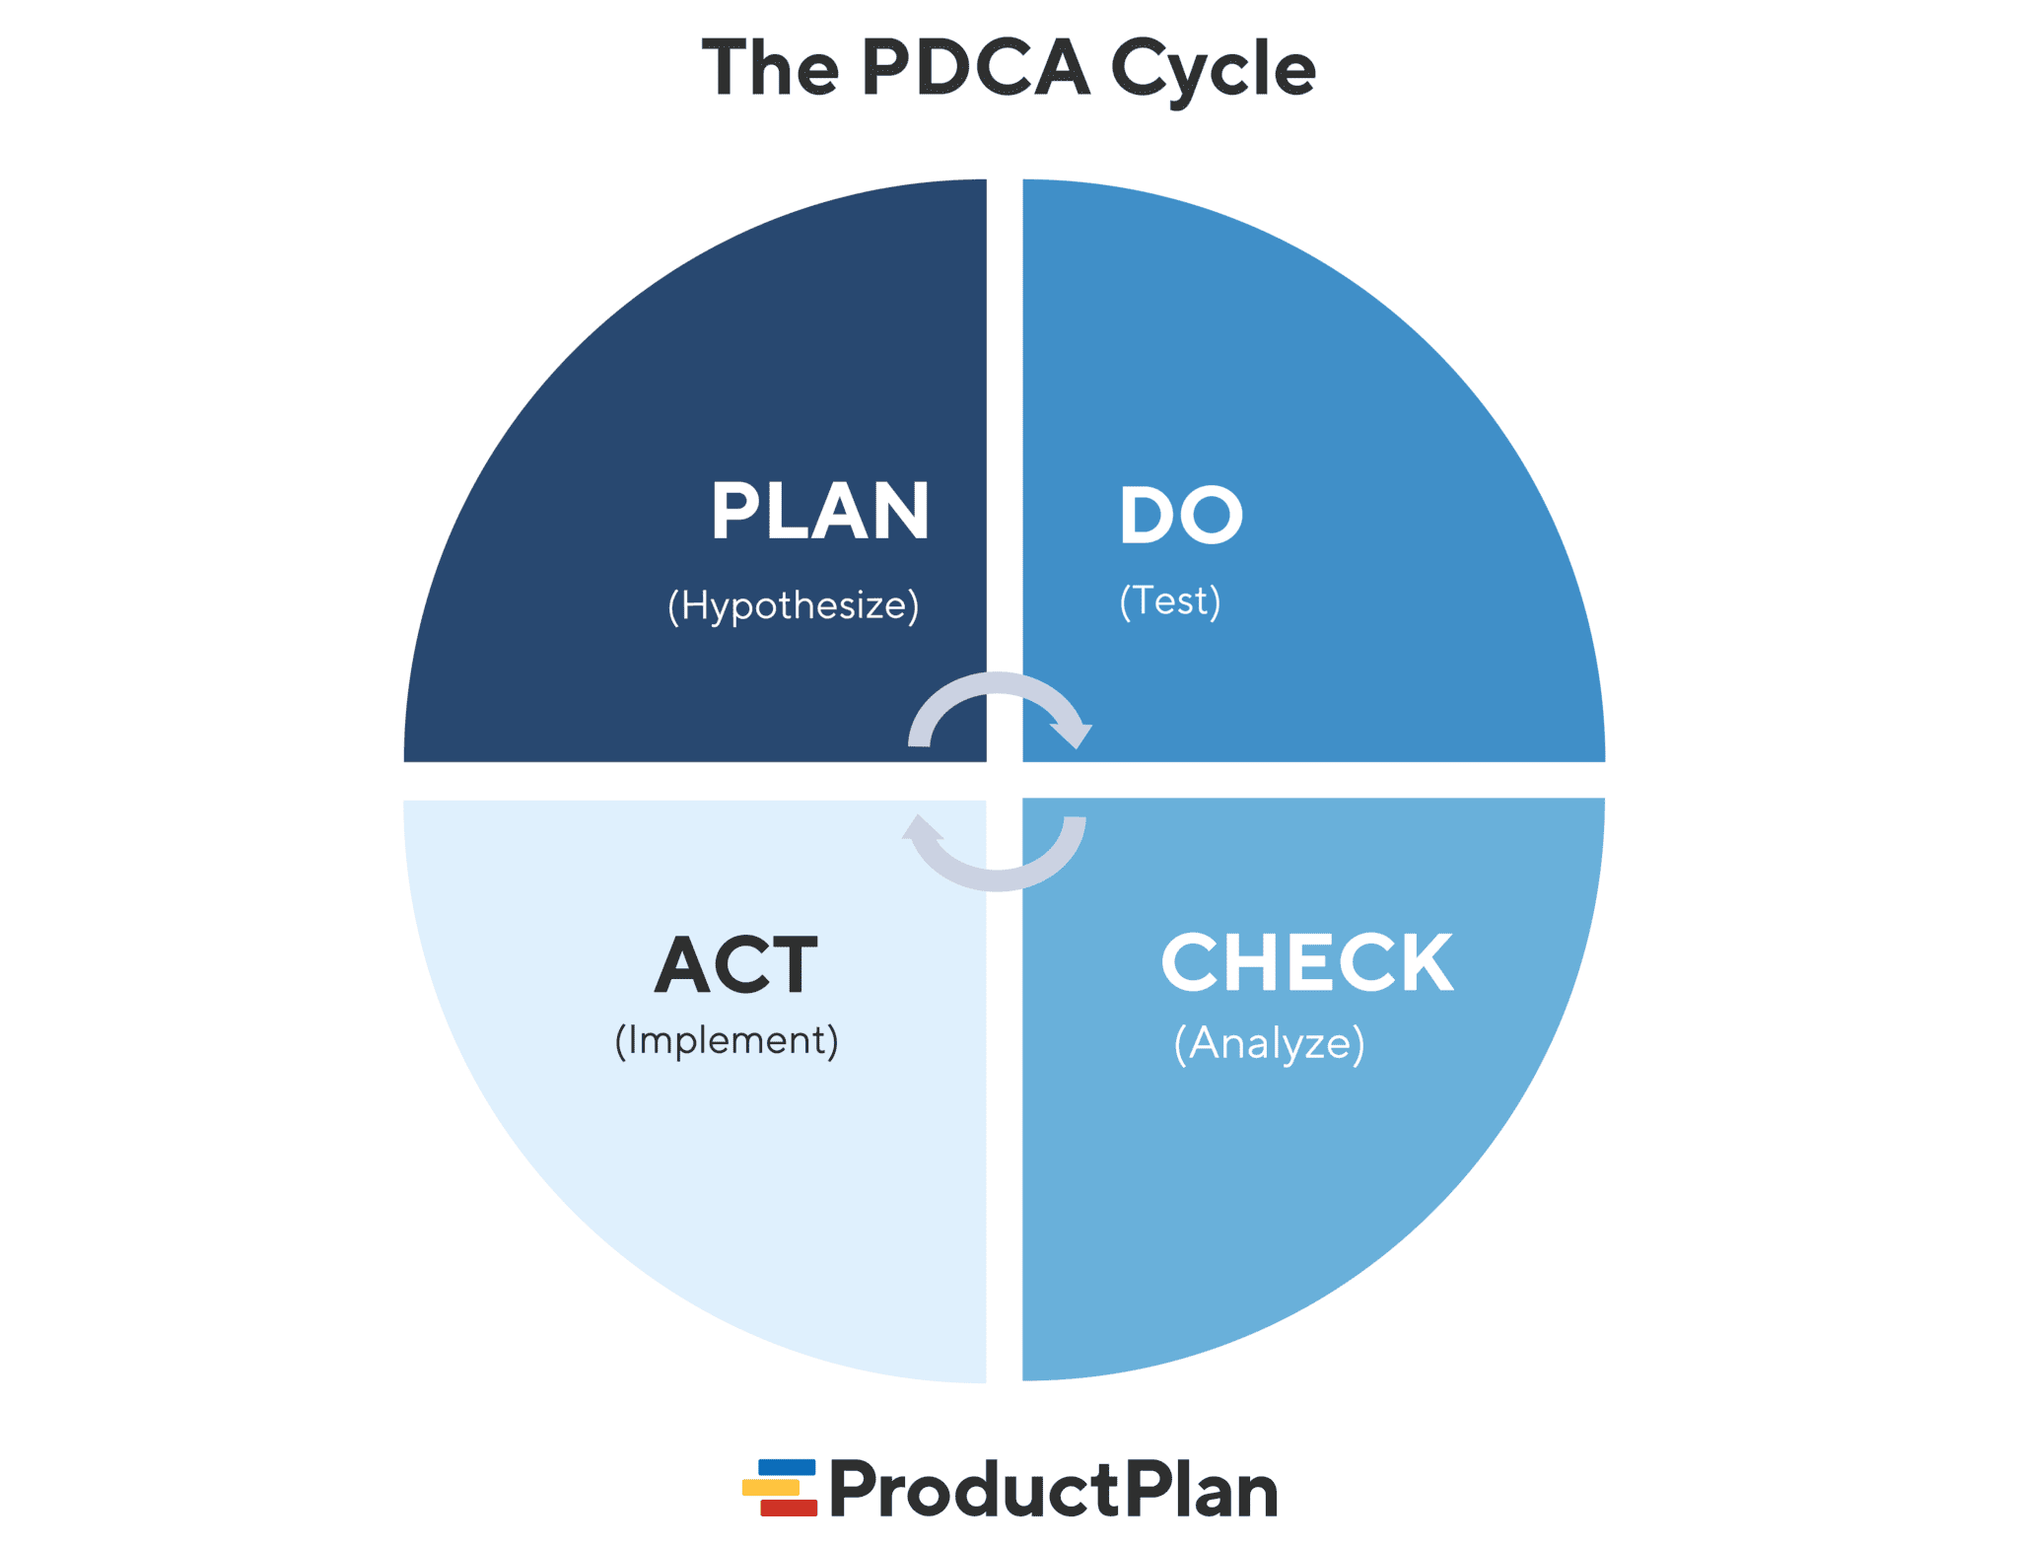

These steps are repeated to ensure that processes followed in the organization are evaluated and improved on a periodic basis.

### Plan

Organizations should always plan and establish the process related objectives and determine the processes that are required to deliver a high-quality end product.

### Do

Development and testing of processes and also “do” changes in the processes if required.

### Check

Monitoring of processes, modifying the processes, and checking whether it meets the predetermined objectives

### Act

A QA tester should implement actions that are necessary to achieve improvements in the processes.

## Definition of Quality

At its core, QA revolves around a clear and measurable definition of "quality." This isn't just about whether something "works," but also encompasses factors like:

* Reliability: How consistently the product performs.
* Performance: How efficiently the product operates.
* Security: How well the product protects data and resists attacks.
* Functionality: Whether the product does what it's supposed to do.
* Usability: How easy the product is to use.
* Also, user satisfaction.

## Quality Control

QC is a software engineering process that is used to ensure quality in a product or a service. It does not deal with the processes used to create a product. It examines the quality of the “end products” and the final outcome. The main objective of a QC is to check whether the products meet the specifications and requirements of the customer. If an issue or problem is identified, it needs to be fixed before delivery to the customer. QC also evaluates people on their quality level skill sets and imparts training and certifications. This evaluation is required for the service based organization and helps to provide “perfect” service to the customers.

| **Quality Assurance (QA)** | **Quality Control (QC)** |
| --- | --- |
| Focuses on providing assurance that the quality requested will be achieved | Focuses on fulfilling the quality requested |
| Technique of managing quality | Technique of verifying quality |
| Involved during the development phase | Involved after the development phase |
| Does not include the execution of the program | Always includes the execution of the program |
| A managerial tool | A corrective tool |
| Process oriented | Product oriented |
| Aim to prevent defects | Aim to identify and improve the defects |
| A preventive technique | A corrective technique |
| A proactive measure | A reactive measure |
| Responsible for the entire SDLC (Software Testing Life Cycle) | Responsible for STLC (Software Testing Life Cycle) |
| Main focus on the intermediate process | Primary focus on final products |
| A less time-consuming activity | A more time-consuming activity |
| Example: Verification | Example: Validation |

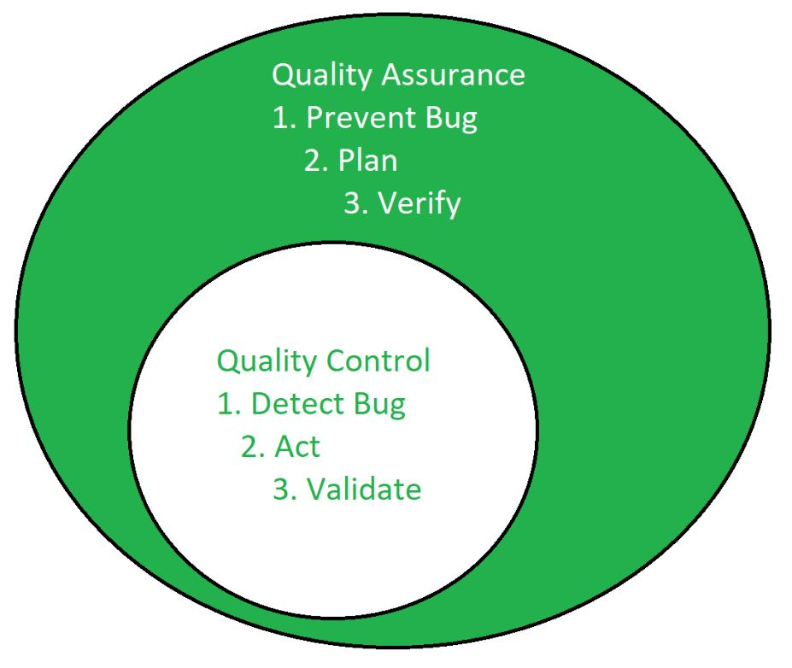

## Software Quality Assurance (SQA)

With respect to software, QA becomes SQA which is about the engineering process that ensures quality. It involves activities related to the implementation of processes, procedures, and standards such as Audits Training that are suitable for the project and implemented correctly. It is a process that works parallel to Software Development that focuses on improving the process of development of software so that problems can be prevented before they become major issues. It is a kind of Umbrella activity that is applied throughout the software process. SQA focuses on the following:

* Portability: It refers to the ability to be easily transferred or adapted to different environments or platforms without needing significant modifications. This ensures that the software can run efficiently across various systems, enhancing its accessibility and flexibility.
* Usability: It refers to how easy and intuitive it is for users to interact with and navigate through the application. A high level of usability ensures that users can effectively accomplish their tasks with minimal confusion or frustration, leading to a positive user experience.
* Reusability: It involves designing components or modules that can be reused in multiple parts of the software or in different projects. This promotes efficiency and reduces development time by eliminating the need to reinvent the wheel for similar functionalities, enhancing productivity and maintainability.
* Correctness: It refers to the ability to produce the desired results under specific conditions or inputs. Correct software behaves as expected without errors or unexpected behaviors, meeting the requirements and specifications defined for its functionality.
* Maintainability: Maintainability refers to how easily it can be modified, updated, or extended over time. Well-maintained software is structured and documented in a way that allows developers to make changes efficiently without introducing errors or compromising its stability.
* Error control: It involves implementing mechanisms to detect, handle, and recover from errors or unexpected situations gracefully. Effective error control ensures that the software remains robust and reliable, minimizing disruptions to users and providing a smoother experience overall.

### Elements of SQA

* Standards: The IEEE, ISO, and other standards organizations have produced a broad array of software engineering standards and related documents. The job of SQA is to ensure that standards that have been adopted are followed and that all work products conform to them.
* Reviews and audits: Technical reviews are a quality control activity performed by software engineers for software engineers. Their intent is to uncover errors. Audits are a type of review performed by SQA personnel with the intent of ensuring that quality guidelines are being followed for software engineering work.
* Testing: Software Testing is a quality control function that has one primary goal—to find errors. The job of SQA is to ensure that testing is properly planned and efficiently conducted for the primary goal of software.
* Error/defect collection and analysis : SQA collects and analyzes error and defect data to better understand how errors are introduced and what software engineering activities are best suited to eliminating them.
* Change management: SQA ensures that adequate change management practices have been instituted.
* Education: Every software organization wants to improve its software engineering practices. A key contributor to improvement is education of software engineers, their managers, and other stakeholders. The SQA organization takes the lead in software process improvement which is a key proponent and sponsor of educational programs.
* Security management: SQA ensures that appropriate process and technology are used to achieve software security.
* Safety: SQA may be responsible for assessing the impact of software failure and for initiating those steps required to reduce risk.
* Risk Management: The SQA organization ensures that risk management activities are properly conducted and that risk-related contingency plans have been established.

## Software Development Life Cycle (SDLC)

SDLC is a structured process that is used to design, develop, and test good-quality software. It is a methodology that defines the entire procedure of software development step-by-step. The goal of the SDLC life cycle model is to deliver high-quality, maintainable software that meets the user’s requirements. SDLC in software engineering models outlines the plan for each stage so that each stage of the software development model can perform its task efficiently to deliver the software at a low cost within a given time frame that meets users requirements.

### Importance of SDLC

* It provides a clear roadmap for the development process, ensuring all team members understand their roles and responsibilities
* By identifying potential risks and challenges early (during the planning and analysis phase), SDLC reduces costly mistakes later in the process
* Testing and verification are built into the process, ensuring that the software meets user requirements and quality standards
* SDLC incorporates risk analysis and mitigation strategies in the planning phase
* Each phase defines the roles of team members (e.g. developers, testers, and analysts), encouraging collaboration and accountability

### Stages of SDLC

SDLC specifies the tasks to be performed at various stages by a software engineer or developer. It ensures that the end product is able to meet the customer’s expectations and fits within the overall budget. Hence, it’s vital for a software developer to have prior knowledge of the software development process. SDLC is a collection of six stages, they are as follows:

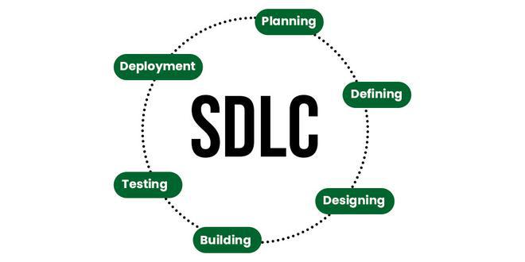

#### Stage-1: Planning and Requirement Analysis

“If you don’t understand the user’s requirements, it doesn’t matter how you code it.” - Ed Yourdon.

Planning is a crucial step in everything. Requirement Analysis is also performed by the developers in this stage which is obtained from customer inputs, and sales department/market surveys. The information from this analysis forms the building blocks of a basic project. The quality of the project is a result of planning. Hence, in this stage, the basic project is designed with all the available information.

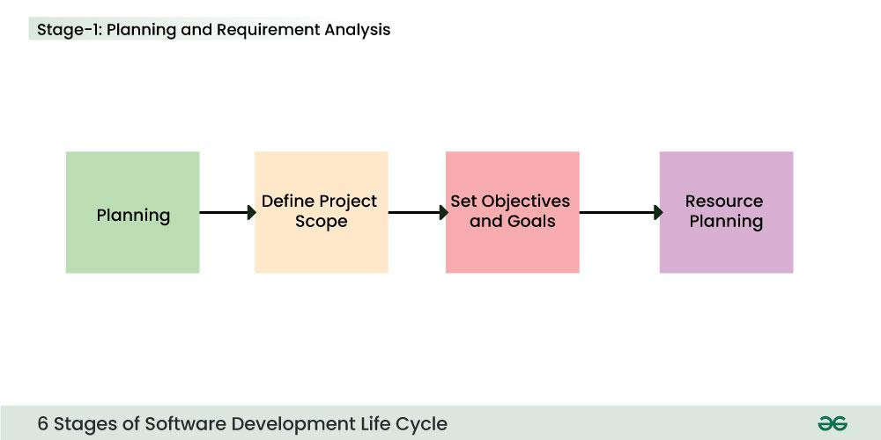

##### In-Depth Activities

* Gathering and analyzing the requirements of the software from stakeholders
* Identifying the purpose, goals, and constraints of the project
* Preparing documentation such as Software Requirement Specification (SRS)
* To conduct product feasibility study in the economical, operational and technical areas

##### Deliverables

* Software Requirements Specification (SRS): includes functional requirements (e.g. order placement, real-time tracking) and non-functional requirements (e.g. app must load in under 2 seconds)

#### Stage-2: Defining Requirements

In this stage, all the requirements for the target software are specified. These requirements get approval from customers, market analysts, and stakeholders which is fulfilled by utilizing SRS (Software Requirement Specification). This is a sort of document that specifies all those things that need to be defined and created during the entire project cycle.

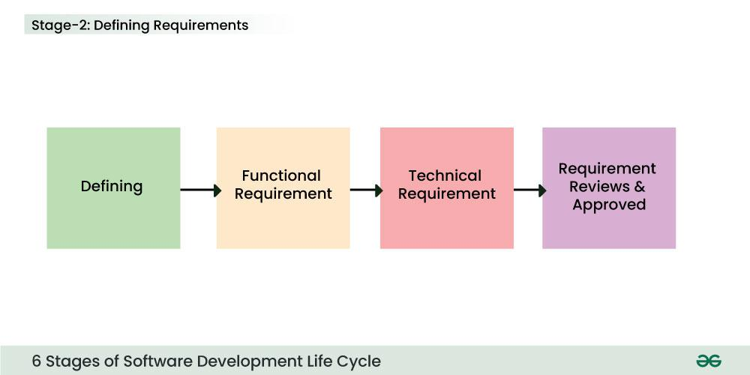

##### In-Depth Activities

* Creating the software architecture and detailed design

##### Deliverables

* Review and approve the requirements for the target software

#### Stage-3: Designing Architecture

SRS is a reference for software designers to come up with the best architecture for the software. Hence, with the requirements defined in SRS, multiple designs for the product architecture are present in the Design Document Specification (DDS) which is assessed by market analysts and stakeholders. After evaluating all the possible factors, the most practical and logical design is chosen for development.

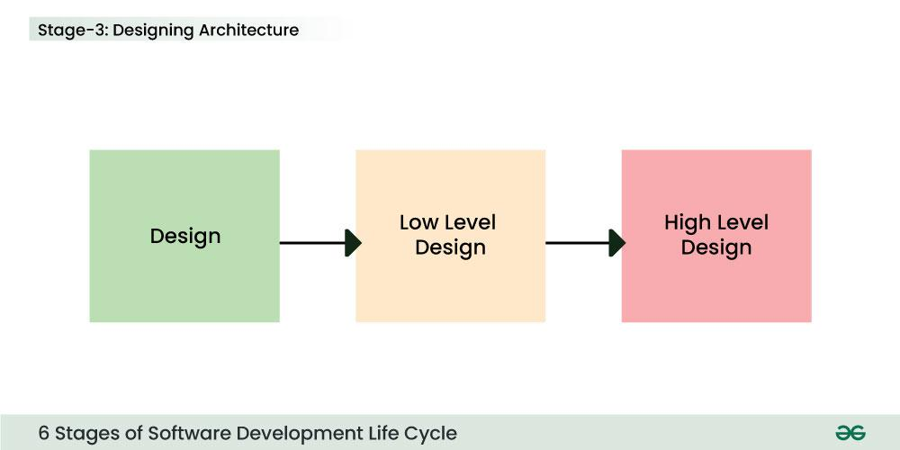

##### In-Depth Activities

* Specifying how the system will work, including database design, user interface design, and algorithms
* Identifying tools, programming languages, and frameworks to be used

##### Deliverables

* Design documents, such as wireframes, UML diagrams, and database schemas

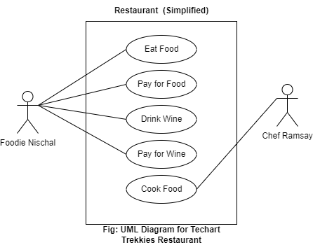

#### Stage-4: Developing Product

At this stage, the fundamental development of the product starts. For this, developers use a specific programming code as per the design in the DDS. Hence, it is important for the coders to follow the protocols set by the association. Conventional programming tools like compilers, interpreters, debuggers, etc. are also put into use at this stage. Some popular languages like C/C++, Python, Java, etc. are put into use as per the software regulations.

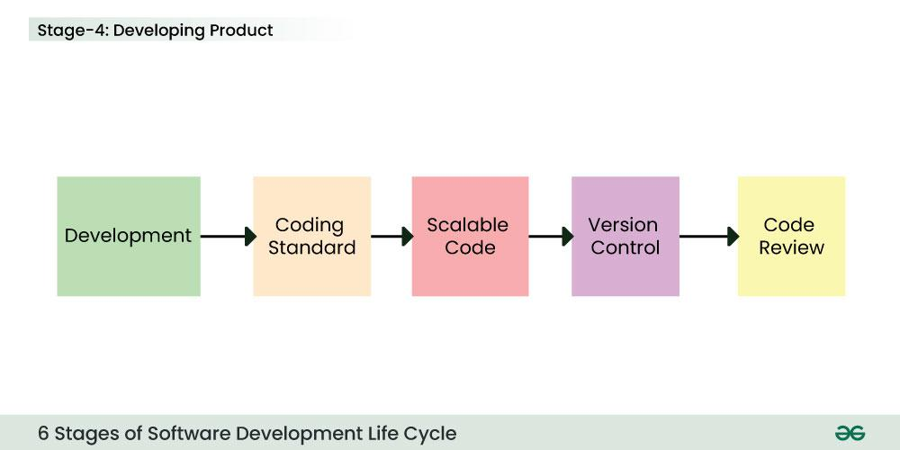

##### In-Depth Activities

* Writing code based on the design documents
* Developers create features and functionalities according to the requirements
* Conducting unit tests during development to catch bugs early

##### Deliverables

* Fully developed software or system modules

#### Stage-5: Product Testing and Integration

After the development of the product, testing of the software is necessary to ensure its smooth execution. Although, minimal testing is conducted at every stage of SDLC. Therefore, at this stage, all the probable flaws are tracked, fixed, and retested. This ensures that the product confronts the quality requirements of SRS.

**Documentation, Training, and Support:** Software Documentation is an essential part of the software development life cycle. A well-written document acts as a tool and means to the information repository necessary to know about software processes, functions, and maintenance. Documentation also provides information about how to use the product. Training in an attempt to improve the current or future employee performance by increasing an employee’s ability to work through learning, usually by changing his attitude and developing his skills and understanding.

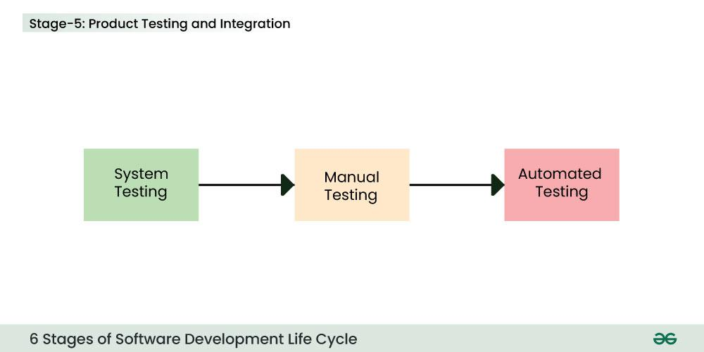

##### In-Depth Activities

* Verifying that the software meets all requirements and is free of bugs
* Conducting various types of testing, such as functional, integration, system, and acceptance testing
* Fixing defects found during testing
* Testing the system as a whole

##### Deliverables

* A bug-free and validated software system

#### Stage-6: Deployment and Maintenance of Products

After detailed testing, the conclusive product is released in phases as per the organization’s strategy. Then it is tested in a real industrial environment. It is important to ensure its smooth performance. If it performs well, the organization sends out the product as a whole. After retrieving beneficial feedback, the company releases it as it is or with auxiliary improvements to make it further helpful for the customers. However, this alone is not enough. Therefore, along with the deployment, the product’s supervision.

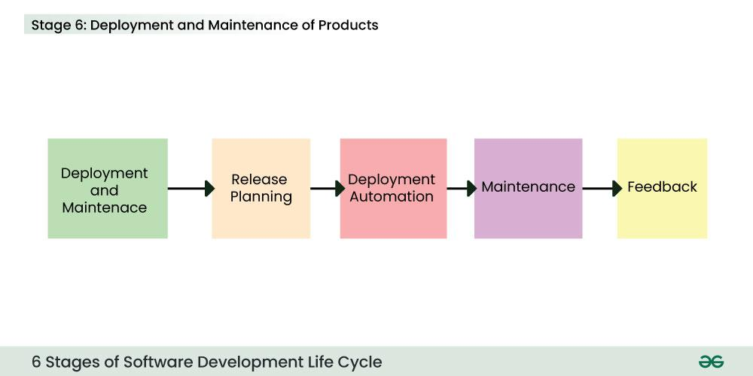

##### In-Depth Activities

* Deploying the software to the live environment
* May be first released to a limited group of users for User Acceptance Testing (UAT) in a real business environment
* Providing training and support to users
* Monitoring performance and making necessary updates or bug fixes
* Adding enhancements based on user feedback

##### Deliverables

* A stable, maintained, and user-adapted software

## Types of SDLC Models

### Waterfall Model

It is the fundamental model of the SDLC. This is a very simple model. It is not in practice anymore, but it is the basis for all other SDLC models. Because of its simple structure, the waterfall model is easier to use and provides a tangible output. In the waterfall model, once a phase seems to be completed, it cannot be changed, and due to this less flexible nature, the waterfall model is not in practice anymore.

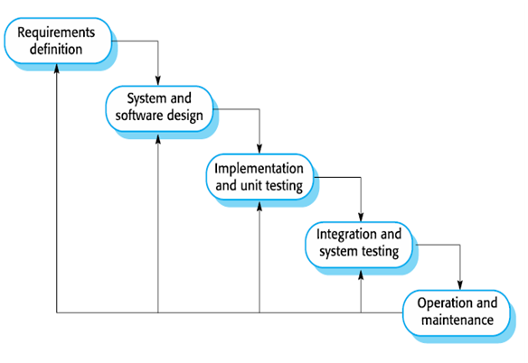

Fig: Waterfall Model

#### Advantage

* Easy to Understand: The Classical Waterfall Model is very simple and easy to understand.
* Individual Processing: Phases in the Classical Waterfall model are processed one at a time.
* Properly Defined: In the classical waterfall model, each stage in the model is clearly defined.
* Clear Milestones: The classical Waterfall model has very clear and well-understood milestones.
* Properly Documented: Processes, actions, and results are very well documented.
* Reinforces Good Habits: The Classical Waterfall Model reinforces good habits like define-before-design and design-before-code.
* Working: Classical Waterfall Model works well for smaller projects and projects where requirements are well understood.

#### Disadvantages

* No Feedback Path: In the classical waterfall model evolution of software from one phase to another phase is like a waterfall. It assumes that no error is ever committed by developers during any phase. Therefore, it does not incorporate any mechanism for error correction.
* Difficult to accommodate Change Requests: This model assumes that all the customer requirements can be completely and correctly defined at the beginning of the project, but the customer’s requirements keep on changing with time. It is difficult to accommodate any change requests after the requirements specification phase is complete.
* No Overlapping of Phases: This model recommends that a new phase can start only after the completion of the previous phase. But in real projects, this can’t be maintained. To increase efficiency and reduce cost, phases may overlap.
* Limited Flexibility: The Waterfall Model is a rigid and linear approach to software development, which means that it is not well-suited for projects with changing or uncertain requirements. Once a phase has been completed, it is difficult to make changes or go back to a previous phase.
* Limited Stakeholder Involvement: The Waterfall Model is a structured and sequential approach, which means that stakeholders are typically involved in the early phases of the project (requirements gathering and analysis) but may not be involved in the later phases (implementation, testing, and deployment).
* Late Defect Detection: In the Waterfall Model, testing is typically done toward the end of the development process. This means that defects may not be discovered until late in the development process, which can be expensive and time-consuming to fix.
* Lengthy Development Cycle: The Waterfall Model can result in a lengthy development cycle, as each phase must be completed before moving on to the next. This can result in delays and increased costs if requirements change or new issues arise.

### Agile Model

The Agile Model in SDLC was mainly designed to adapt to changing requests quickly. The main goal of it is to facilitate quick project completion. The agile model refers to a group of development processes. These processes have some similar characteristics but also possess certain subtle differences among themselves.

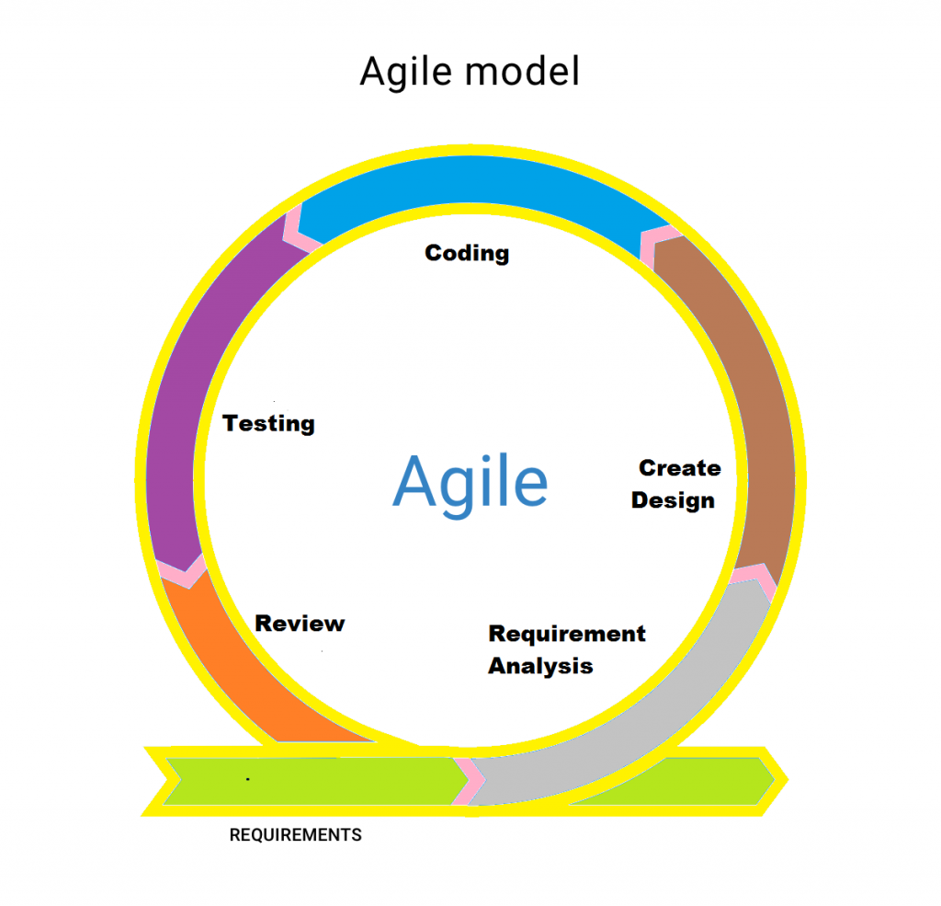

Fig: Agile Model

#### Advantage

* Focus on Customer Value: Agile places a high priority on providing customers with value by attending to their requirements and preferences. Agile guarantees that the most important features are produced first and that iterative changes are driven by customer feedback by dividing work down into small, manageable tasks.
* Enhanced Team Morale and Motivation: Agile gives teams the freedom to own their work and decide together. Team members feel motivated, proud, and owned when they have this autonomy together with a focus on providing value and ongoing growth.
* Stakeholder Collaboration: Throughout the development process, agile promotes strong coordination between product owners, developers, and other stakeholders. Better communication, a common understanding of the objectives, and ongoing feedback are all fostered by this partnership, which produces results that are higher quality and boost stakeholder satisfaction.
* Early and Continuous Delivery: Agile encourages the tiny, incremental releases of functional software. This gives early access to observable progress and facilitates early input and validation for stakeholders. Continuous delivery reduces risks by spotting problems early on and taking action to fix them.
* Delivering high-quality software: It is a key component of agile development, and this is emphasized by techniques like continuous integration, automated testing, and frequent inspection and modification. Agile guarantees that the software satisfies the required standards and lowers the likelihood of faults by integrating quality assurance throughout the development process.

#### Disadvantage

* Lack of Predictability: Project timeframes and outcomes might be difficult to predict with accuracy due to Agile iterative and incremental methodology. Stakeholders who need set budgets or timeframes may find this unpredictability troublesome.
* Dependency on Customer Availability: Agile highly depends on ongoing customer and stakeholder feedback and participation. Customers who are unavailable or who don’t know enough about the domain can impede development and slow it down.
* Scaling Agile: While Agile works effectively for small to medium-sized teams working on relatively basic projects, scaling Agile methods to bigger teams or more complicated projects can be more difficult. As the project grows, it gets harder to maintain coordination, alignment, and communication.
* Dependency on Team Dynamics: Agile’s focus on self-organizing, cross-functional teams with the authority to reach decisions together is paramount. Inadequate communication within the team or a lack of experience or expertise among team members can negatively affect output quality and productivity.
* Increased Overhead: Planning, coordinating, and communicating take more time and effort when using agile frameworks like Scrum. This overhead can take a lot of time, especially for projects with short deadlines or small teams.

### Iterative Model

In this model, each cycle results in a semi-developed but deployable version; with each cycle, some requirements are added to the software, and the final cycle results in the software with the complete requirement specification.

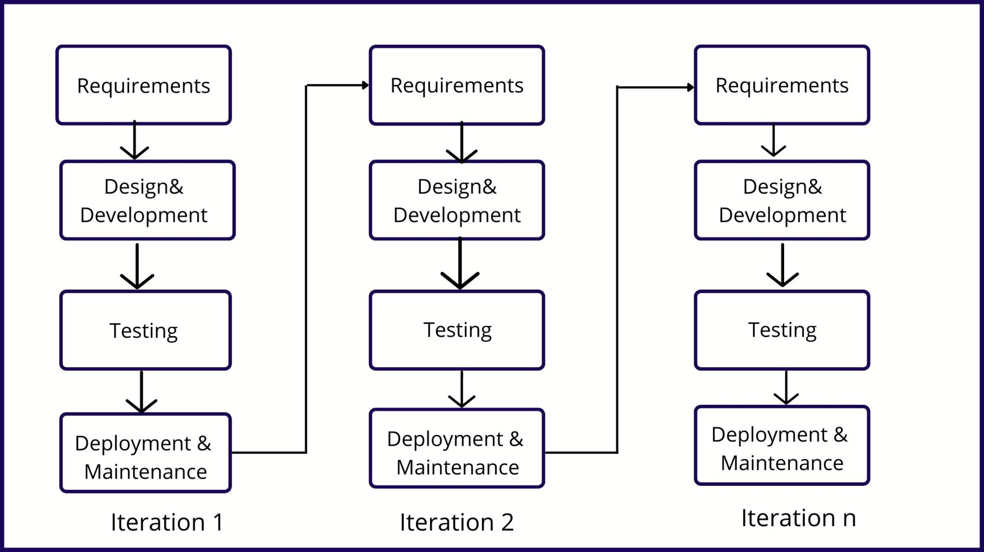

Fig: Iterative Model

#### Advantages

* Phase Containment of Errors: Errors are detected and fixed as close to their source as possible, reducing costly rework and delays.
* Collaboration: Continuous collaboration between business owners and developers ensures the product meets business needs and improves with feedback at each iteration.
* Flexibility: The model allows for easy incorporation of new requirements or features in subsequent iterations, ensuring the product evolves with the business.
* Testing and Feedback: Regular testing and feedback cycles help identify and fix issues early, improving the product’s quality and relevance.
* Faster Time to Market: Incremental development allows parts of the product to be delivered sooner, enabling user feedback while further improvements are made.
* Risk Reduction: Continuous feedback and testing help identify risks early, reducing the likelihood of costly errors and delays.

#### Disadvantages

* Difficult to incorporate change requests: The major drawback of the iterative waterfall model is that all the requirements must be clearly stated before starting the development phase. Customers may change requirements after some time but the iterative waterfall model does not leave any scope to incorporate change requests that are made after the development phase starts.
* Incremental delivery not supported: In the iterative waterfall model, the full software is completely developed and tested before delivery to the customer. There is no scope for any intermediate delivery. So, customers have to wait a long for getting the software.
* Overlapping of phases not supported: Iterative waterfall model assumes that one phase can start after completion of the previous phase, But in real projects, phases may overlap to reduce the effort and time needed to complete the project.
* Risk handling not supported: Projects may suffer from various types of risks. But, the Iterative waterfall model has no mechanism for risk handling.
* Limited customer interactions: Customer interaction occurs at the start of the project at the time of requirement gathering and at project completion at the time of software delivery. These fewer interactions with the customers may lead to many problems as the finally developed software may differ from the customers’ actual requirements.

### Spiral Model

The Spiral Model in SDLC is one of the most crucial SDLC models that provides support for risk handling. It has various spirals in its diagrammatic representation; the number of spirals depends upon the type of project. Each loop in the spiral structure indicates the Phases of the Spiral Model.

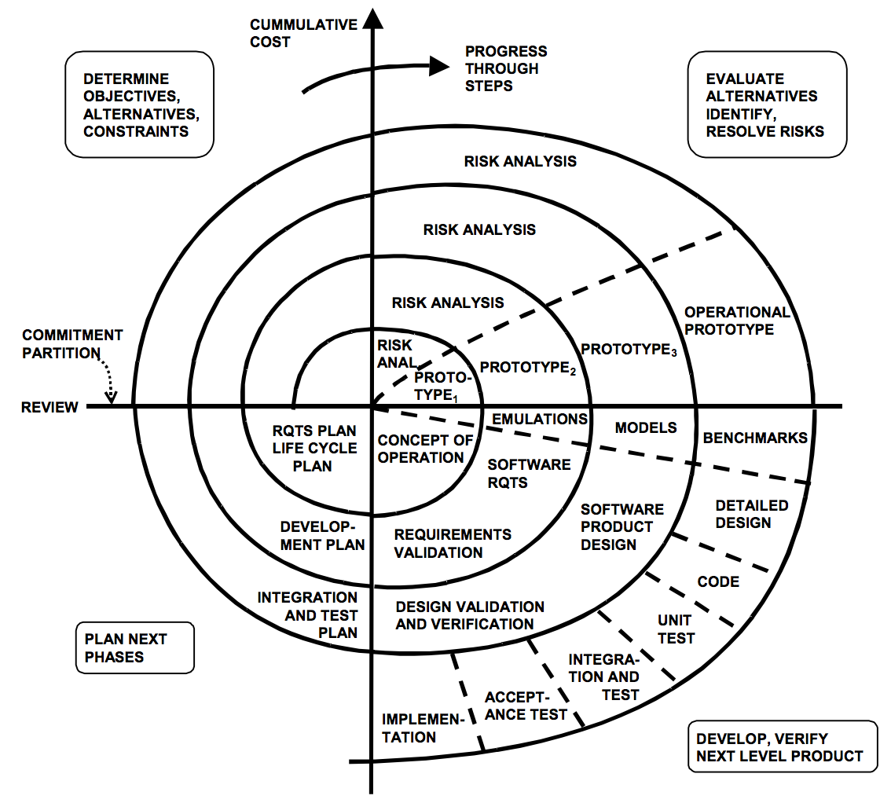

### Advantages

* Risk Handling: The projects with many unknown risks that occur as the development proceeds, in that case, Spiral Model is the best development model to follow due to the risk analysis and risk handling at every phase.
* Good for large projects: It is recommended to use the Spiral Model in large and complex projects.
* Flexibility in Requirements: Change requests in the Requirements at a later phase can be incorporated accurately by using this model.
* Customer Satisfaction: Customers can see the development of the product at the early phase of the software development and thus, they habituated with the system by using it before completion of the total product.
* Iterative and Incremental Approach: The Spiral Model provides an iterative and incremental approach to software development, allowing for flexibility and adaptability in response to changing requirements or unexpected events.
* Emphasis on Risk Management: The Spiral Model places a strong emphasis on risk management, which helps to minimize the impact of uncertainty and risk on the software development process.
* Improved Communication: The Spiral Model provides for regular evaluations and reviews, which can improve communication between the customer and the development team.
* Improved Quality: The Spiral Model allows for multiple iterations of the software development process, which can result in improved software quality and reliability.

### Disadvantages

* Complex: The Spiral Model is much more complex than other SDLC models.
* Expensive: Spiral Model is not suitable for small projects as it is expensive.
* Too much dependability on Risk Analysis: The successful completion of the project is very much dependent on Risk Analysis. Without very highly experienced experts, it is going to be a failure to develop a project using this model.
* Difficulty in time management: As the number of phases is unknown at the start of the project, time estimation is very difficult.
* Complexity: The Spiral Model can be complex, as it involves multiple iterations of the software development process.
* Time-Consuming: The Spiral Model can be time-consuming, as it requires multiple evaluations and reviews.
* Resource Intensive: The Spiral Model can be resource-intensive, as it requires a significant investment in planning, risk analysis, and evaluations.

### V-Shaped Model

It is executed in a sequential manner in V-Shape. Each stage or phase of this model is integrated with a testing phase. After every development phase, a testing phase is associated with it, and the next phase will start once the previous phase is completed, i.e. development & testing. It is also known as the verification or validation model.

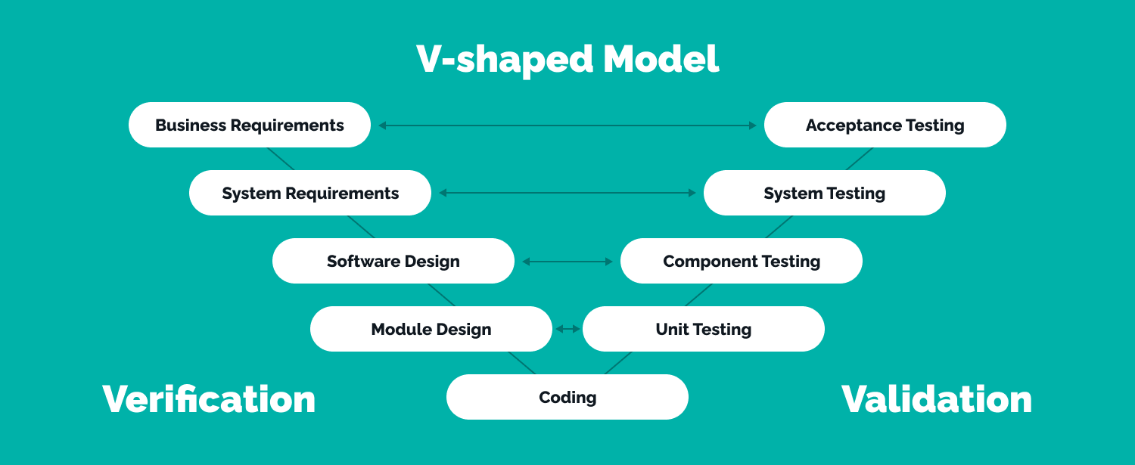

### Advantages of V-Model

* This is a highly disciplined model and Phases are completed one at a time.
* V-Model is used for small projects where project requirements are clear.
* Simple and easy to understand and use.
* This model focuses on verification and validation activities early in the life cycle thereby enhancing the probability of building an error-free and good quality product.
* It enables project management to track progress accurately.
* Clear and Structured Process: The V-Model provides a clear and structured process for software development, making it easier to understand and follow.
* Emphasis on Testing: The V-Model places a strong emphasis on testing, which helps to ensure the quality and reliability of the software.
* Improved Traceability: The V-Model provides a clear link between the requirements and the final product, making it easier to trace and manage changes to the software.
* Better Communication: The clear structure of the V-Model helps to improve communication between the customer and the development team.

### Disadvantages of V-Model

* High risk and uncertainty.
* It is not good for complex and object-oriented projects.
* It is not suitable for projects where requirements are not clear and contain a high risk of changing.
* This model does not support iteration of phases.
* It does not easily handle concurrent events.
* Inflexibility: The V-Model is a linear and sequential model, which can make it difficult to adapt to changing requirements or unexpected events.
* Time-Consuming: The V-Model can be time-consuming, as it requires a lot of documentation and testing.
* Over Reliance on Documentation: The V-Model places a strong emphasis on documentation, which can lead to an overreliance on documentation at the expense of actual development work.

### Big Bang Model

The Big Bang Model in SDLC is a term used to describe an informal and unstructured approach to software development, where there is no specific planning, documentation, or well-defined phases.

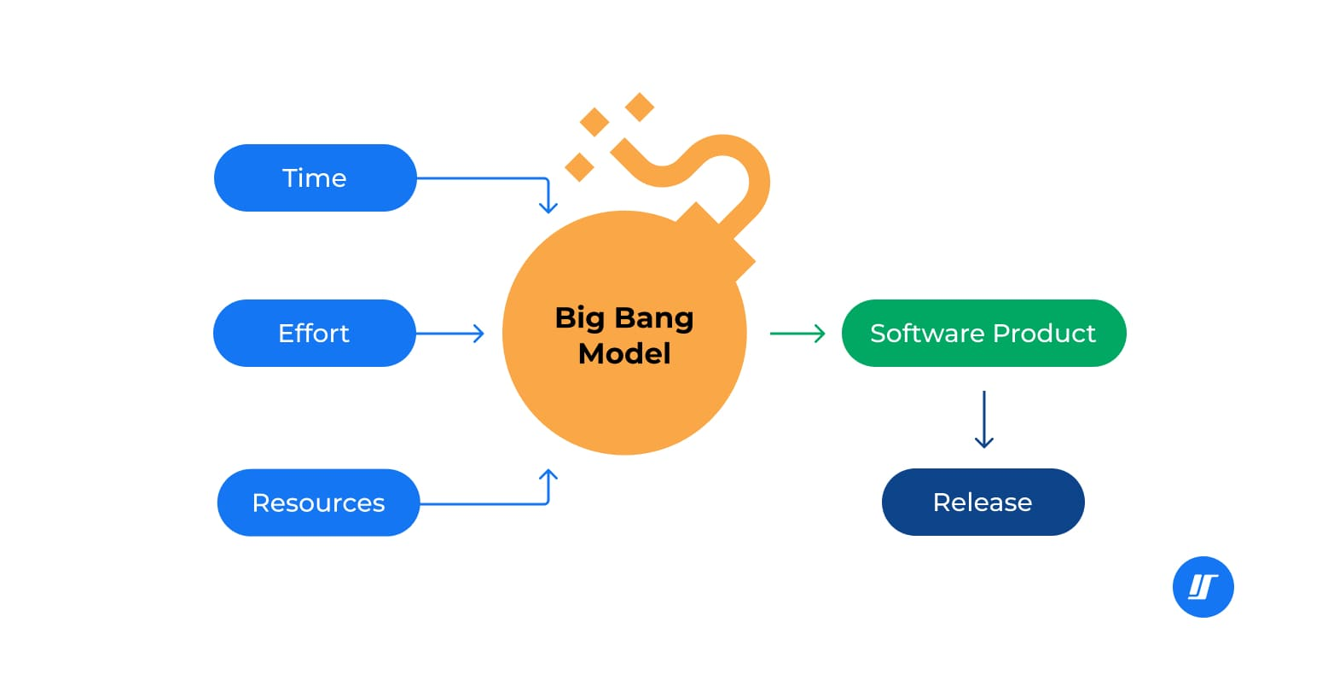

### Advantages

* There is no planning required for this.
* Suitable for small projects
* Very few resources are required.
* As there is no proper planning hence it does not require managerial staffs
* Easy to implement
* It develops the skills of the newcomers
* Very much flexible for the developers working on it

### Disadvantages

* Not suitable for large projects.
* Highly risky model and uncertain
* Might be expensive if requirements are not clear
* Poor model for ongoing projects

## Techniques of testing

Software testing techniques are methods and approaches used to ensure that software performs as expected and meets the requirements. They can be broadly categorized into static testing (no code execution) and dynamic testing (code execution).

### Need of testing techniques

* Ensure comprehensive test coverage.
* Improve testing efficiency.
* Detecting defects early.
* Enhance software quality.
* Reduce risks and identify vulnerabilities.
* Optimize test case design.
* Address various testing scenarios.
* Support automation for faster execution.
* Build confidence in software reliability.

### Static Testing

Definition: Testing performed without executing the code. Focuses on reviewing, analyzing, and verifying the software artifacts (documents, designs, or code).

Purpose: To identify defects early in the development process, saving time and costs.

Performed During: Verification phase (static testing verifies the correctness of the system).

Key Artifacts Reviewed: Requirements, design documents, test plans, and source code.

### Advantage

* Detects defects early in development.
* Reduces development and testing costs.
* Prevents runtime errors by addressing issues before code execution

### Example

* Reviewing requirement specifications for inconsistencies.
* Checking the design for missing modules or workflows.
* Analyzing code for syntax errors, unused variables, or dead code.

### Dynamic Testing

Definition: Testing performed by executing the software to check its behavior under various conditions.

Purpose: To validate that the software works as intended and meets requirements.

Performed During: Validation phase (dynamic testing validates the system's behavior).

Key Focus Areas: Functionality, performance, reliability, and usability.

## Different Software Testing Techniques

### Equivalence Partitioning

Concept: Divides input data into valid and invalid partitions to minimize the number of test cases while ensuring broad coverage.

Example: For an age input field with a valid range of 1-100:

Valid partition: 1 to 100.

Invalid partitions: Less than 1 (<1) or greater than 100 (>100).

Test cases: Any number between 1 and 100, numbers less than 1 (e.g., -1), and numbers greater than 100 (e.g., 101).

### Boundary Value Analysis

Concept: Focuses on testing the limits of input ranges where errors are more likely to occur (i.e., boundary conditions).

Example: For an age range of 1-100: Boundary test cases: 0, 1, 100, and 101.

The idea is to test values at, below, and above the boundary.

### Decision Table Testing

Concept: Uses a table to outline input combinations and their expected outcomes to ensure all scenarios are covered.

Example: In a discount system with "Customer Type" (Regular/Premium) and "Purchase Amount" (e.g., $50 or $100):

Test cases: If a regular customer buys $50, they may get no discount; if a premium customer buys $100, they may get a 10% discount.

#### Decision Table

| Customer Type | Purchase Amount | Discount |
| --- | --- | --- |
| Regular | $50 | No |
| Regular | $100 | 5% |
| Premium | $50 | 5% |
| Premium | $100 | 10% |

### State Transition Testing

Concept: Tests systems where output depends on the current state, ensuring transitions between states work as expected.

Example: In a login system:

States: Logged Out → Logged In → Incorrect Password → Logged Out

Test cases: Transition from "Logged Out" to "Logged In" on correct credentials, from "Logged In" to "Incorrect Password" on wrong input, etc.

### Use Case testing

Concept: Tests the software against real-world scenarios to ensure it meets user requirements.

Example: In an e-commerce platform:

Use cases: "Add Item to Cart," "Proceed to Checkout," "Apply Discount Code," and "Confirm Payment."

### Error Guessing

Concept: Leverages the tester’s intuition and experience to guess areas likely to contain defects.

Example: Focusing on input fields where users might enter special characters or invalid data, such as "Email Address" or "Phone Number" fields.

### All-Pair Testing Technique

Concept: Tests all possible combinations of pairs of input parameters.

Example: For three settings (A, B, C) with two options each (On/Off), you would test:

(A=On, B=On), (A=On, B=Off), (A=Off, B=On), (A=Off, B=Off).

This ensures that all combinations of two settings are tested.

### Cause-Effect Technique

Concept: Maps cause (inputs) to their expected effects (outputs) to verify relationships.

Example: In a loan application:

Inputs like “Income” and “Credit Score” influence the “Loan Approval” decision.

Test cases: Check the outcomes when different combinations of income and credit score are provided (e.g., low income, high credit score → approval).

### Risk Coverage

Concept: Prioritizes testing of the areas with the highest risk of failure.

Example: Testing critical features like payment processing in an e-commerce app more rigorously than less impactful features like profile customization.

### Statement Coverage

Concept: Ensures that every line of code is executed at least once.

Example: In an order processing function, all lines of code should be tested to ensure they perform their intended operations.

### Branch Coverage

Concept: Tests each decision point in the code to ensure both true and false conditions are executed.

Example: For an if-else statement:

Test both the "true" condition (if) and the "false" condition (else) to ensure both paths are covered.

### Path Coverage

Concept: Ensures that all possible execution paths through the code are exercised during testing.

Example: In a loop: Test scenarios where the loop executes multiple times and where the loop is skipped (i.e., not entered).

### Test Case Format

A test case document is a detailed set of instructions or scenarios designed to validate whether a software application is functioning correctly according to requirements. It usually includes information about test inputs, execution conditions, expected outcomes, and test steps. Below is a simple outline of what a typical test case document contains:

* Test Case ID: Unique identifier for the test case.
* Test Case Title: A concise title describing the test scenario.
* Module/Feature Name: The module or feature being tested.
* Preconditions: Any conditions or setup required before executing the test.
* Test Data: Input data required to execute the test.
* Steps to Execute: Step-by-step instructions to perform the test.
* Expected Result: The expected outcome of the test.
* Actual Result: The actual outcome observed during the test.
* Test Environment: Information about the environment (e.g., browser, OS, version).
* Status: Pass/Fail/Blocked/Not Executed.
* Remarks/Comments: Additional details or notes.

## Types of Testing

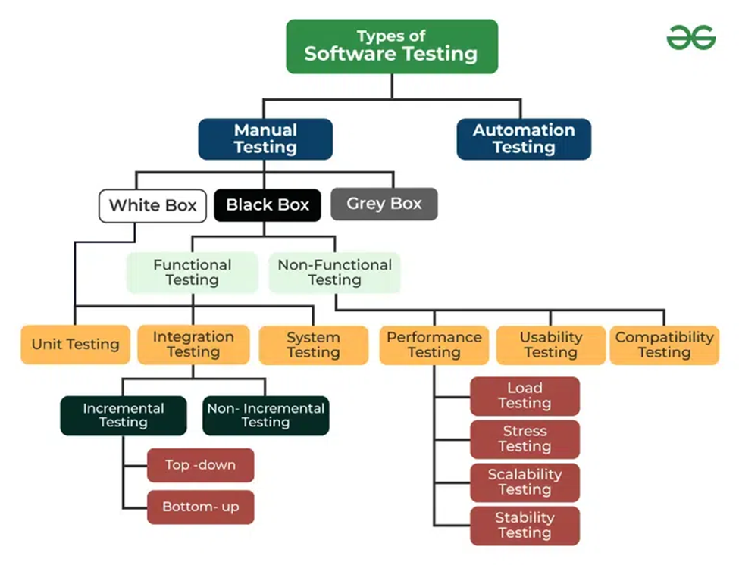

### Manual Testing

Manual Testing is the process of manually executing test cases without the use of automation tools.

#### Pros

* Flexibility: Manual testing is flexible and can be performed without a predefined script. Testers can adapt to changes in the requirements or product during testing.
* Suitable for Small Projects: For smaller projects or when there is limited time or resources for automation, manual testing is often more practical and cost-effective.
* Exploratory Testing: Testers can explore the application beyond predefined test cases, identifying unexpected issues and scenarios that automated tests may miss.
* Better for Usability Testing: Manual testing is essential for evaluating user experience (UX) and interface design, as human testers can assess ease of use, intuitive design, and other subjective factors.
* No Setup Required: Manual testing doesn't require setting up or maintaining complex test automation frameworks, which can save time in some cases.

#### Cons

* Time-Consuming: Manual testing is typically slower than automated testing, especially for repetitive tests, which can significantly delay the testing process.
* Error-Prone: Testers can make mistakes during manual execution, leading to inconsistent or inaccurate results. This can reduce the reliability of test outcomes.
* Limited Coverage: It can be difficult to achieve comprehensive test coverage through manual testing, particularly for large or complex applications.
* High Cost in the Long Run: For projects that require extensive testing, manual testing can become costly over time due to the need for continuous tester involvement.
* Inability to Perform Regression Testing Efficiently: As software evolves, regression testing becomes necessary to ensure existing functionality is not broken. Manual testing can be slow and inefficient for repeated regression tests.

### Automation Testing

Automation Testing involves using tools and scripts to automatically execute test cases, compare results with expected outcomes, and report the findings.

#### Pros

* Faster Execution: Automated tests can run much faster than manual tests, especially for repetitive tasks, allowing more tests to be completed in less time.
* Reusability: Once test scripts are created, they can be reused across different versions of the application, making it cost-effective in the long run.
* Improved Test Coverage: Automation allows for more extensive test coverage, especially in large applications. It can execute thousands of test cases across different configurations in a short period.
* Accuracy and Reliability: Automated testing eliminates human errors that can occur in manual testing, ensuring consistent and reliable results.
* Regression Testing: Automation is particularly effective for regression testing, where you need to test the same functionalities after every update or change.
* Continuous Integration (CI): Automation supports CI/CD pipelines, enabling continuous testing with every new build, ensuring quick feedback on the software quality.
* Cost-Effective for Long-Term Projects: Although the initial investment in automation tools and script development can be high, automation becomes more cost-effective over time for ongoing or repetitive testing.

#### Cons

* High Initial Setup Cost: Automation requires significant upfront investment in tools, frameworks, and resources. Developing the automation scripts also takes time and expertise.
* Not Suitable for Short-Term Projects: For small or short-term projects, the time and cost to set up automation may not justify the benefits.
* Maintenance of Scripts: Automated test scripts require regular updates and maintenance, especially when the application or system undergoes changes. This can become time-consuming and resource-intensive.
* Lack of Human Judgment: Automated tests cannot mimic human intuition, and may miss issues related to user experience, visual appearance, or usability that manual testing can catch.
* Limited Flexibility: Automation works best for stable and well-defined test cases. It may not be as effective for exploratory testing or adapting to rapid changes in the application.
* Initial Learning Curve: Setting up automation frameworks and writing scripts requires skilled testers with expertise in programming and test automation tools, which can lead to a learning curve for the team.

## Types of manual testing

### White Box Testing

White box testing is a method where the tester has full visibility of the internal workings of the application. Testers design test cases based on the code, logic, and structure of the software. They test individual functions, branches, loops, conditions, and paths in the program.

#### Pros

* Code Coverage: Ensures that the internal code is tested thoroughly, leading to higher code coverage, including edge cases and rare scenarios.
* Early Detection of Bugs: Bugs can be detected and fixed early because testing is done from the code’s perspective, revealing potential vulnerabilities and performance issues.
* Optimization: It helps identify unnecessary code and optimize it, improving the efficiency of the application.
* Test Security: Helps in identifying security vulnerabilities in the code, such as access control flaws or incorrect handling of sensitive data.
* Comprehensive Testing: White box testing provides deep insights into the application's internals, ensuring that all possible paths and branches are tested.

### Black Box Testing

Black box testing focuses on testing the functionality of the software without looking at its internal code. Testers provide inputs and observe the outputs, ensuring that the system behaves as expected from the user's perspective. It's often based on functional specifications or user stories.

#### Pros

* User Perspective: It simulates how an end user interacts with the software, ensuring that the system meets user expectations and requirements.
* No Knowledge of Code Required: Testers don’t need to know the internal workings or programming knowledge of the application, making it accessible to non-developers.
* Effective for Large Applications: It can be used to test large systems and complex applications, especially in cases where the internal details are too complex to review manually.
* Prevents Overlooking Requirements: Focuses on the user’s needs, helping ensure the system meets the functional and non-functional requirements.

### Gray Box Testing

Gray box testing combines aspects of both white box and black box testing. The tester has partial knowledge of the internal workings of the system but tests the system primarily as an external user. This allows for more targeted and effective testing than black box testing, while still simulating user behavior.

#### Pros

* Balanced Approach: Gray box testing allows testers to approach the system from both the internal code perspective and the external user experience, offering more balanced and thorough testing.
* More Efficient: Since testers have partial knowledge of the system, they can more efficiently design test cases, focusing on areas with higher risk or critical functionality.
* Uncovers Hidden Defects: Combines the strengths of both black box and white box testing, enabling testers to find defects that might be missed by either approach individually.
* Improved Security Testing: Offers a better understanding of system vulnerabilities, as it allows testers to evaluate the system's response to unauthorized access or improper data inputs.

## Types of Black Box Testing

### Functional Testing

Functional testing is a type of software testing that focuses on verifying whether the application's functions work as expected according to the requirements and specifications. This testing ensures that the system behaves correctly from a functional perspective, typically by inputting data and comparing the output with the expected results. It primarily tests the "what the system does" rather than the internal workings or code of the system.

#### Benefits of Functional Testing

* Bug-free product: Functional testing ensures the delivery of a bug-free and high-quality product.
* Customer satisfaction: It ensures that all requirements are met and ensures that the customer is satisfied.
* Testing focused on specifications: Functional testing is focused on specifications as per customer usage.
* Proper working of application: This ensures that the application works as expected and ensures proper working of all the functionality of the application.
* Improves quality of the product: Functional testing ensures the security and safety of the product and improves the quality of the product.

### Unit testing

Unit testing is a method of testing individual units or components of a software application. It is typically done by developers and is used to ensure that the individual units of the software are working as intended. Unit tests are usually automated and are designed to test specific parts of the code, such as a particular function or method. Unit Testing basically included both White Box Testing and Black Box Testing.

#### Advantages

* It helps to identify bugs early in the development process before they become more difficult and expensive to fix.
* It helps to ensure that changes to the code do not introduce new bugs.
* It makes the code more modular and easier to understand and maintain.
* It helps to improve the overall quality and reliability of the software.

#### Example

* In a program we are checking if the loop, method, or function is working fine.
* Misunderstood or incorrect, arithmetic precedence.
* Incorrect initialization.

### Gorilla Testing

Gorilla testing is an informal and aggressive type of software testing in which the tester focuses on a specific part or module of the software and tests it repeatedly and intensively. The goal is to break the system by stressing it through a high volume of test cases, often without following a structured test plan or design

#### Example

* Click repeatedly on the "Add to Cart" button as quickly as possible, even when the page is loading.
* Test adding multiple items in rapid succession, ignoring any product-specific logic (like quantity limits).
* Try adding items from different categories, without considering the normal flow.
* Simulate edge cases such as adding more items than available in stock, to see how the system handles inventory overflows.
* Use incorrect input for quantities, prices, or user login details to test how the system responds to unusual data.

### Integration testing

Integration testing is a type of software testing where individual software modules or components are combined and tested as a group. The main purpose of integration testing is to ensure that the different modules of the software work together as expected. Unlike unit testing, which tests individual components in isolation, integration testing focuses on the interactions between those components.

#### Advantage

* Detects Interaction Issues: It helps to find problems that occur when different components or systems interact, such as incorrect data exchanges, missing communication between modules, or errors in data handling.
* Improved System Reliability: Integration testing ensures that various modules or components work together smoothly, which results in a more reliable system overall.
* Early Detection of Bugs: It allows developers and testers to identify issues early in the development process, reducing the cost and time needed to fix problems later.
* Prevents Regression: When integrating modules, you can ensure that newly integrated features do not affect the existing functionality of the system.
* Test in a Controlled Environment: It provides an opportunity to test the interaction between components in a controlled and isolated environment before deployment.

#### Example

Interaction between a User Authentication module and a Payment Processing module in an online shopping system. The test checks if, after a user successfully logs in, they are able to make a payment and complete their purchase. For instance, a test might simulate logging in with valid credentials, selecting a product, and proceeding to checkout. The expected result is that the user can make the payment without any issues, ensuring that both modules interact correctly.

### System testing

System Testing is a type of software testing that involves testing the complete and fully integrated software product. It is the final level of testing before the product is released to users or stakeholders. The goal of system testing is to validate the overall functionality, performance, security, and other aspects of the system to ensure it works as expected in a real-world environment.

#### Advantage

* Complete Test Coverage: Ensures that all aspects of the system are tested as a whole.
* Identifies Major Issues: Helps in identifying any defects that may arise when different components interact.
* Validation Against Requirements: Verifies that the system meets the original business and technical requirements.

#### Example

For an e-commerce application, system testing would involve testing all components like the user login, product search, order placement, payment processing, and email notification systems to ensure they all work together seamlessly. It also includes testing the system’s performance, security (e.g., ensuring payment data is encrypted), and response time during high traffic conditions.

### End to End Testing

End-to-End (E2E) testing is a type of testing where the complete workflow of an application is tested from start to finish. The primary goal is to ensure that the flow of the application behaves as expected in a real-world scenario. This testing checks the integration and interaction of various components in the application, including the user interface (UI), database, APIs, and external systems.

#### Advantage

* Ensures Application Flow: Verifies the complete functionality and performance of the application, ensuring it behaves as expected from the user’s perspective.
* Validates System Integration: Confirms that different modules and services of the system interact and work together seamlessly.
* Detects Critical Issues: Helps identify bugs in the workflow that might not appear in unit or integration tests.
* Improves User Experience: By mimicking real-world scenarios, E2E testing ensures that users will have a smooth and consistent experience.
* Reduces Risks: Ensures that key business workflows are functional, reducing the likelihood of failure in production.
* Automation-Friendly: Modern tools enable automating E2E tests, making them faster and reducing manual effort.

#### Example

A tester is performing E2E testing on a pet insurance website by starting with user registration and logging in. They test purchasing an insurance policy, including selecting a plan, providing pet details, and completing payment. The tester then adds another pet under the same account, updates user information such as the address and payment method, and ensures the updates are saved. Finally, they validate that confirmation emails, along with policy documents, are received and accurately reflect the transaction details.

### Smoke Testing

Smoke Testing is a preliminary level of software testing that checks whether the major functionalities of an application are working correctly. It is often called "build verification testing" because it ensures that the software build is stable enough for further, more in-depth testing. It focuses on identifying critical issues that could prevent the application from functioning properly, like crashes, missing functionality, or major UI defects.

#### Advantage

* Early Detection of Critical Issues: Identifies show-stopping bugs early in the testing cycle, saving time and effort.
* Quick Feedback: Provides fast verification of whether the software build is functional and stable.
* Saves Time and Resources: Helps avoid wasting time testing a broken or unstable build.
* Improves Quality Assurance: Ensures major features are working before proceeding to detailed testing.
* Automation-Friendly: Can be easily automated to quickly validate builds.
* Supports Continuous Integration: Fits well with CI/CD pipelines by validating builds before deploying to further stages.

#### Example

Smoke testing was conducted on an e-commerce application to ensure the critical functionalities were working. The tester verified that the homepage loaded correctly, users could log in with valid credentials, search for products, add items to the cart, and proceed to checkout. They also confirmed that the payment gateway initiated successfully and the logout functionality worked as expected. This quick validation ensured the build was stable enough for further testing.

### Sanity testing

Sanity Testing is a subset of regression testing performed after minor changes or bug fixes in an application to ensure that the specific functionality or feature is working as expected. It focuses on verifying that the changes or fixes did not break any related functionality and that the system is stable for further testing.

#### Advantage

* Quick Validation: Verifies the correctness of specific changes or bug fixes quickly.
* Saves Time: Focuses only on the impacted areas, avoiding exhaustive testing.
* Enhances Efficiency: Ensures the testing team doesn’t waste time on irrelevant parts of the application.
* Minimizes Risks: Confirms that minor updates haven’t introduced critical issues in the system.
* Supports Agile Development: Ideal for iterative cycles where frequent minor changes occur.

#### Example

A food delivery app after a bug fix in the credit card payment process. The tester verified that users could place an order, complete the payment using a credit card, and receive an order confirmation. They also checked related areas like other payment methods to ensure the fix did not impact those functionalities. This quick validation ensured the app was ready for further detailed testing.

### Happy path testing

Happy Path Testing is a type of testing that focuses on verifying the system's functionality using the simplest and most straightforward scenario, where everything works as expected and no errors or edge cases are encountered. It ensures that the application performs correctly under ideal conditions.

#### Example

Happy path testing was performed on an online ticket booking system. The tester searched for tickets by entering valid city names and dates, selected a ticket, entered valid passenger details, made a successful payment, and verified that the booking confirmation page displayed correctly. This ensured the application's core workflow worked seamlessly under ideal conditions.

### Monkey testing

Monkey Testing is an exploratory testing technique where the tester interacts with the application randomly without predefined test cases or scenarios. The purpose is to identify unexpected crashes, bugs, or errors by mimicking random user behavior. It is often used to test the stability and robustness of an application.

#### Example

Monkey testing was performed on a social media app by entering random text in fields, tapping buttons in no particular order, rapidly switching between pages, and uploading invalid file formats. The tester observed the app’s behavior to ensure it did not crash or freeze under unpredictable usage, highlighting potential weaknesses in its stability.

### Acceptance testing

Acceptance Testing is a type of software testing performed to determine whether a system meets the business requirements and is ready for deployment. It is typically carried out by the end users or clients to ensure the software is functioning as expected and satisfies the acceptance criteria before going live.

#### Advantages

* Validates Business Requirements: Ensures the software meets the business needs and requirements set by the client or stakeholders.
* Confirms User Expectations: Verifies that the software delivers the functionality that the end-users expect and can use effectively.
* Reduces Risks: By catching issues early in the acceptance phase, it minimizes the risk of problems once the software is deployed.
* Improves Customer Satisfaction: Ensures the final product aligns with customer expectations, which helps build trust and satisfaction.
* Clear Go/No-Go Decision: Provides a definitive decision on whether the system is ready for production or if more work is needed.

### Alpha Testing

Alpha Testing is the first phase of testing conducted by the development team in-house before the product is released to external users. It focuses on identifying bugs and issues that might affect the system’s functionality, ensuring the product meets the specified requirements.

#### Advantage

* Early Detection of Bugs: Identifies major defects before the product is released to external testers.
* Improves Product Quality: Helps refine the product and make it more stable.
* Cost-Effective: Detects issues early, preventing expensive fixes later.

#### Example

During alpha testing of a mobile app, the development team checks the core functionalities like login, registration, and navigation. They identify a crash when entering invalid data into the registration form and fix it before the beta release.

### Beta Testing

Beta Testing is performed by a selected group of external users (customers or potential users) after alpha testing. It helps identify unforeseen issues in real-world usage and ensures the product is ready for launch.

#### Advantage

* Real-World Feedback: Provides insights from actual users, improving user experience.
* Unbiased Testing: Identifies issues that internal testers may not have considered.
* Reduces Risk of Failures: Helps ensure the product is stable and works across various environments.

#### Example

A beta testing phase is conducted for a new video streaming app, where users outside the company test the app on different devices. They report issues with video buffering on older smartphones, which are addressed before the public release.

### Operational Acceptance Testing

Operational Acceptance Testing (OAT) verifies that the application is ready for production and meets operational requirements such as performance, security, and scalability. It ensures the system functions correctly in the live environment.

#### Advantage

* Ensures Operational Readiness: Verifies that the system is robust and ready for deployment in a real-world environment.
* Validates Non-Functional Requirements: Confirms that performance, security, and other operational aspects meet the necessary standards.
* Reduces Production Issues: Helps avoid disruptions by ensuring the system performs smoothly post-deployment.

#### Example

During OAT of an e-commerce platform, the testing team checks server load times, user traffic handling, security features, and backup systems to ensure the platform can handle high traffic on sale days without crashing.

### Non-Functional Testing

Non-Functional Testing refers to testing the non-functional aspects of a system, such as its performance, scalability, usability, security, and reliability. Unlike functional testing, which focuses on the specific actions and behaviors of the software, non-functional testing evaluates how well the system performs under various conditions and ensures it meets specific operational criteria.

#### Advantages

* Ensures System Performance: Validates how the system performs under normal and peak conditions, ensuring it handles large amounts of data, users, or transactions.
* Improves User Experience: Assesses usability, ensuring the system is user-friendly and intuitive.
* Ensures Reliability and Availability: Tests the system's stability, uptime, and ability to function without failure over time.
* Validates Security: Helps identify potential vulnerabilities, ensuring the system is secure and data is protected from breaches.
* Optimizes Scalability: Ensures the system can scale efficiently to handle increased workloads and grow with business needs.
* Compliance with Standards: Ensures the system meets industry standards and regulatory requirements.

### Security Testing

Security Testing ensures that an application or system is free from vulnerabilities, threats, or risks that could lead to unauthorized access or data breaches. The primary goal is to identify potential weaknesses in the system's security mechanisms and ensure that sensitive data and resources are protected.

#### Penetration/Pan Testing

Penetration Testing (also called Pen Testing) is a type of security testing where ethical hackers simulate real-world cyber-attacks to identify vulnerabilities in a system, network, or application. Its goal is to uncover security weaknesses before attackers can exploit them, allowing the organization to fix those issues proactively

### Performance Testing

Performance Testing is a type of non-functional testing that evaluates how a system performs under various conditions. It checks the speed, scalability, stability, and responsiveness of an application to ensure it meets the performance requirements. This testing is critical for applications expected to handle heavy traffic or large-scale operations.

#### Load Testing

Load Testing is a type of performance testing that evaluates how a system performs under expected user loads. The primary goal is to ensure the system can handle the anticipated traffic without compromising functionality, speed, or stability. Load testing helps identify bottlenecks, set performance benchmarks, and prepare the system for real-world usage.

#### Stress Testing

Stress Testing is a type of performance testing used to evaluate a system's behavior under extreme or beyond-normal operating conditions. Its purpose is to determine the system's breaking point and how it recovers after failure. Stress testing helps identify vulnerabilities, such as memory leaks, crashes, or degraded performance, under high load scenarios.

#### Scalability Testing

Scalability Testing is a type of non-functional testing that evaluates a system's ability to handle increasing workloads or users efficiently. The goal is to determine whether the system can scale up (by adding resources) or scale out (by adding nodes or instances) without compromising performance, stability, or usability.

#### Volume Testing

Volume Testing is a type of performance testing that evaluates a system's ability to handle a large volume of data. It examines how the system performs when subjected to an increasing or maximum amount of data in the database, files, or input/output operations. The goal is to ensure that data-intensive applications remain stable and efficient under heavy data loads.

#### Endurance Testing

Endurance Testing, also known as Soak Testing, is a type of performance testing that evaluates the stability and performance of a system under a sustained workload over a prolonged period. The purpose is to identify issues such as memory leaks, resource degradation, or performance bottlenecks that might arise due to extended usage.

### Usability Testing

Usability Testing is a type of testing focused on evaluating how easy and user-friendly a system or application is for its intended audience. The primary goal is to ensure that users can efficiently complete tasks and have a positive experience while using the product. It involves real users interacting with the application to identify issues in design, navigation, or functionality.

#### Exploratory Testing

Exploratory Testing is an unscripted and dynamic testing approach where testers explore the application to identify defects, usability issues, and inconsistencies. It is typically performed without predefined test cases, allowing testers to leverage their knowledge and creativity to uncover hidden issues. This approach is particularly useful for discovering edge cases or unexpected behaviors.

#### Cross Browser Testing

Cross-Browser Testing ensures that a web application functions correctly across multiple browsers and devices. It verifies that the application provides a consistent user experience, regardless of the browser or platform used by the end-user.

#### Accessibility Testing

Accessibility Testing ensures that a web or mobile application is usable by people with disabilities, such as visual, auditory, or motor impairments. The goal is to meet accessibility standards (e.g., WCAG) and provide an inclusive user experience.

### Compatibility Testing

Compatibility Testing is a type of testing that evaluates how well a software application functions across different environments, including various operating systems, browsers, devices, network conditions, and hardware configurations. The goal is to ensure that the application performs consistently and reliably for all users, regardless of the platform they are using.

#### Ad-Hoc Testing

Ad-Hoc Testing is an informal and unstructured type of testing where the tester randomly explores the application without any formal test cases or plans. The goal is to uncover defects that might be overlooked in regular structured testing. It relies on the tester's experience and intuition to detect issues quickly.

#### Database Testing

Database Testing involves verifying the integrity, consistency, and accuracy of the data within a database. It focuses on ensuring that data is correctly stored, retrieved, and manipulated. It also includes testing SQL queries, stored procedures, and data consistency across the database.

#### Browser Compatibility Testing

Browser Compatibility Testing ensures that a web application works across multiple web browsers, such as Chrome, Firefox, Safari, and Edge. The focus is on ensuring the application behaves the same way regardless of the browser used by the end-user.

#### Regression Testing

Regression Testing involves re-running previously executed test cases to ensure that recent changes (bug fixes, enhancements, etc.) haven't introduced new defects into the existing functionality of the application.

#### Graphical User Interface Testing

GUI Testing evaluates the visual elements and user interface of an application to ensure that it is user-friendly, visually appealing, and meets design specifications. It involves testing elements like buttons, icons, menus, and layout consistency.

## Type of Testing Tools

Testing tools are software applications or frameworks designed to help testers and developers automate the testing process, improve efficiency, and ensure the quality of the software product. They assist in various types of testing, such as functional, performance, security, and more.

### Automated Testing Tools

* Appium: An open-source tool for automating mobile apps across iOS and Android. It supports multiple languages, including Java, JavaScript, and Python, and allows for cross-platform mobile testing.
* Cucumber: A BDD (Behavior-Driven Development) tool that lets testers write tests in plain English, making it easier for non-technical stakeholders to understand the tests. It works well with tools like Selenium for web testing.
* Ranorex: An all-in-one test automation tool that supports desktop, mobile, and web applications. Ranorex offers a user-friendly interface and supports both coded and no-code approaches for automation.

### Performance Testing Tools

* WebLOAD: A performance testing tool that provides load, stress, and scalability testing for web and mobile applications. It allows testers to simulate thousands of users to evaluate the performance of web applications.
* Apache JMeter: An open-source tool primarily designed for load testing and performance measurement of web applications. JMeter can simulate a heavy load on a server, group of servers, or network to test its strength and analyze overall performance.
* NeoLoad: A performance testing tool designed for web and mobile applications. It is used to simulate traffic and measure the application's behavior under load to identify performance bottlenecks.

### Cross-Browser Testing Tools

* BrowserStack: A popular cross-browser testing tool that allows users to test their applications across different browsers and devices in real-time. It supports both automated and manual testing of mobile and web applications.
* Testsigma: A test management tool with built-in cross-browser testing capabilities. It allows teams to automate and execute test cases across different browsers, devices, and environments.
* Testim: An AI-powered test automation platform that provides cross-browser testing, allowing users to easily create and maintain tests for web applications on various browsers and devices.
* Perfecto: A cloud-based testing platform for mobile and web applications. It supports cross-browser testing on real devices and browsers, offering comprehensive test automation, performance, and security testing capabilities.

### Integration Testing Tools

* Citrus: A test framework designed for integration testing, which supports API, web service, and messaging protocol testing. It enables testing of message exchanges between services and systems in a distributed environment.
* FitNesse: A collaborative testing framework that supports both acceptance testing and integration testing. FitNesse uses a wiki interface to define tests, making it easier for non-technical stakeholders to contribute to the testing process.
* TESSY: A testing tool used for module and integration testing of embedded systems. TESSY automates the process of testing the integration of software modules in embedded applications.

### Unit Testing Tools

* Jenkins: An open-source automation tool used for continuous integration (CI) that can be configured to run unit tests automatically every time changes are pushed to the code repository. It integrates with popular unit testing tools like JUnit and PHPUnit.
* PHPUnit: A unit testing framework for PHP applications. It helps developers write and run tests for small units of code, ensuring that individual functions or methods work correctly.
* JUnit: A widely-used unit testing framework for Java applications. It allows developers to write repeatable tests for individual units of code and integrates seamlessly with CI tools like Jenkins to automate the testing process.

### Mobile Testing Tools

* Appium: An open-source tool that automates mobile applications across iOS and Android platforms. It supports multiple programming languages (Java, Python, Ruby, etc.) and is widely used for both native and hybrid mobile apps.
* Robotium: A test automation framework for Android applications. It helps automate black-box testing of Android apps, particularly for testing user interactions. It's suitable for both functional and regression testing.
* Test IO: A cloud-based mobile testing platform that connects testers with real devices to perform manual and automated testing. It supports testing on multiple mobile devices and browsers, providing valuable feedback on mobile application quality.

### Bug Tracking Tools

* Trello: A simple, visual project management tool that is often used for bug tracking. It allows teams to create boards, lists, and cards to track bugs and tasks. While not specifically designed for bug tracking, it can be customized to manage bugs in small teams or projects. JIRA: A widely-used issue tracking and project management tool by Atlassian.
* JIRA is specifically designed to track and manage bugs, user stories, tasks, and other project-related issues. It integrates well with other tools like GitHub and Jenkins for continuous integration.
* GitHub Issues: A feature of GitHub that allows developers to track and manage bugs, tasks, and feature requests within a GitHub repository. It's widely used for open-source projects and small development teams, enabling bug reporting directly within the GitHub environment.

# CONCLUSION

In conclusion, this report has provided a fundamental introduction to Quality Assurance, highlighting its proactive role in ensuring product excellence. By emphasizing defect prevention, implementing robust processes, and integrating QA throughout the development lifecycle, organizations can significantly improve product reliability and customer satisfaction. The principles outlined in this report serve as a foundation for further exploration and implementation of comprehensive QA strategies.